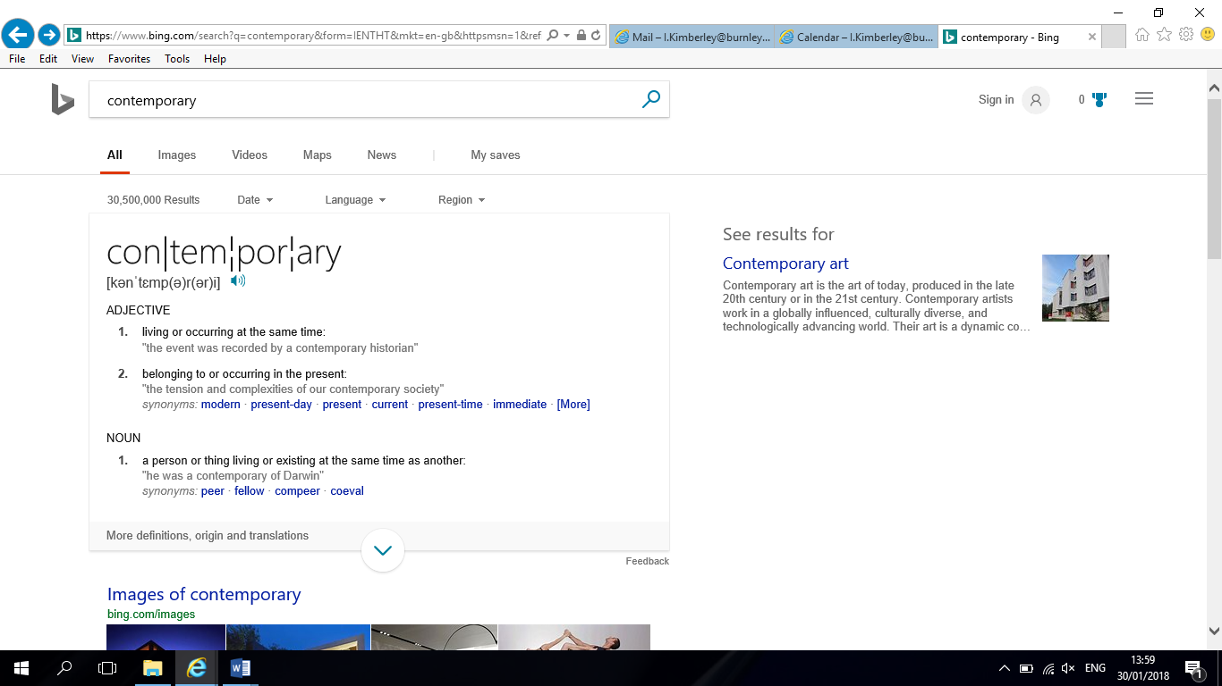Contemporary Issues?

Use the following websites to identify a current issue in education.

[www.tes.com](http://www.tes.com)

<https://www.gov.uk/government/organisations/department-for-education>

<http://feweek.co.uk/>

<https://www.gov.uk/government/organisations/ofsted>

|  |
| --- |
| Why is it an issue? |
| Who does it affect? |
| How does it affect them? |
| How is the issue being addressed? |

Brief the class on your findings in no more than 2 mins.